# 4. Implementation

The implementation phase is the third phase of SDLC where visions and plans becomes reality. It simply means carrying out the activities described in work plan.

## 4. 1 Programming language

Programming language is a computer language which helps to develop program to control the behavior and output of a machine through accurate algorithms, similar to the human communication process. Among many programming language I have used mainly ‘PHP’ to develop ‘The computer Store’.

PHP

PHP: Hypertext preprocessor is widely used, open source scripting language. It is compatible with almost all server used today and supports wide range of database. It is object oriented language generally used to develop web based application. It execute at server side and generate dynamic pages.

(<https://www.eukhost.com/blog/webhosting/advantages-of-php-programming/>)

Reasons to use PHP:

* It supports multiple platform. It can run on both Unix and window servers.
* PHP has powerful output buffering feature so that headers come before contents.
* It can be used with large number of relational database management systems. supports almost all used in today’s life.
* PHP5 is fully object oriented language and its platform independence and speed on linux server helps to develop large and complex web applications.

So PHP5 is being used with MYSQL database for this project.

## 4.2 Development Environment

The tools, techniques and IDE, I have used to develop this project are listed bellow:

* Net Beans/Sublime text editors:

I have used Net Beans IDE 8.0 and sublime text editor as IDE to complete this project. Net beans is free, open source which help to develop desktop, mobile and web application with Java, JS, HTML5,PHP etc.

* Visual Paradigm 8.0:

It is software design tools helps to model software development process. I have used this to design and develop different diagrams like use case diagram.

* Star UML:

It is also a development tool that supports Unified modeling language and I have used this to develop class diagrams.

* Figma:

This is collaborative interface design tool which helps to design prototypes. I have used this tool to design User interface during this project.

* Xampp Control panel V3.2.1:

It is a free open source cross-platform webserver solution package. I have used this tools to run Apache server for application.

## 4.3 Deployment Strategy:

After the development of the project, it should be deployed so that user can get access to application. Deployment is one of the key phase in implementation because we can only use the application if it is deployed successfully. As this project is online base we need webserver where we can store all the files and folder. From the server, we can get access to application. All the deployment will be done after proper testing in local host.

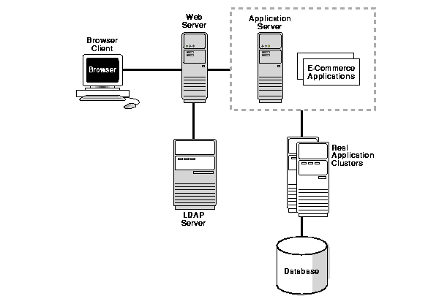

To deploy the project, the domain name of the web application should be registered and then hosted in the web server. All the files stored in the application server can be accessed by using this domain. All the data are stored in database. Now the system is ready to use and client can put their request through browser using hosted domain.

## 4.4 User Training

The web application has user friendly interface which will be easier to use. However user can easily use the application because of easy navigation and form validation. A short user training file will be prepared and kept in the website so that user can view it in difficulty. All the features provided by the application and How to use them are shortly documented. This file can be download by clicking in help option from the website.

## 4.5 Conclusion

In this chapter 4, I have reported about the programming language used to build this system with its benefit. I have also listed all the tools, IDEs that were used in development of the project. The deployment strategy of the application is clearly identified and described with the diagram. About user training and user guide to use the application is described above.

# 5. Other Project Issues

## 5.1 Project Management

Deadlines are fixed. In order to complete project on time, I have used “Work Break Structure” technique. WBS visually defines the scope into manageable chunks that a project team can understand, as each level of the work breakdown structure provides further definition and detail. This allows to understand the What, When, Why and How of the desired result.

Also, I have used Time Estimation technique in order to complete the project in right time. Accurate time estimation helps for good project management. It drives the setting deadlines and hence will impact on other people’s assessment of our reliability and competence of project. Along with the time estimation, a milestones were set for the project. Milestones have fixed time but not duration as shown below:

|  |  |  |
| --- | --- | --- |
| WBS | Task name | Required Days |
| 1 | *Project Proposal* | *5* |
| 2 | *Project Management* | *4* |
| 2.1 | Project Scope | 1 |
| 2.2 | Deliverable Structure | 1 |
| 2.3 | Schedule | 2 |
| 3. | *Analysis* | *15* |
| 3.1 | System Requirement | 6 |
| 3.2 | User Requirement | 9 |
| 4. | *Design* | *25* |
| 4.1 | Interface design | 8 |
| 4.2 | Coding design | 14 |
| 4.3 | Final design | 3 |
| 5. | *Testing* | *16* |
| 5.1 | Black box testing | 8 |
| 5.2 | White box testing | 8 |
| 6. | *Report* | *22* |
| 6.1 | Presentation | 7 |
| 6.2 | Final Document | 15 |
|  | **Total days** | **87** |

*Table: Time Estimate*

|  |  |  |
| --- | --- | --- |
| S/N | Milestones | Date |
| 1 | Project Proposal | 14th April 2018 |
| 2 | Project Management | 18th April 2018 |
| 3 | Requirement analysis | 3rd May 2018 |
| 4 | Interface design | 11th May 2018 |
| 5 | Coding | 25th May 2018 |
| 6 | Testing | 13th Jun 2018 |
| 7 | Report preparation | 5th July 2018 |

A total of 87 days was estimated in order to complete the project. This could not happen because the design and coding was not completed in estimated time. They were unable to complete on 11th May and 25th May. Due to the poor time estimation during analysis, I was unable to complete the project on time. Also this was my first project, I was unexperienced about the actual time that could take to complete following task. So, the analysis of requirement with respect to time was not carried out so well.

## 5.2 Risk Management

Risk management is the process of identification, analysis and acceptance of uncertainty in investment decisions. Thus we need to identify the risk and manage it before it creates problems in website. The knowledge of risks will give various options on how to deal with potential problems. If we define objective without taking the risks into consideration, chances are that they will lose direction once any of these risks hit. (CareersinAudit.com, 2018).

In the proposed project, some of the identified risk, likelihood, their consequences, impact and action to tackle them were tabulated. During the development phase some of those risk were faced.

Risks

* Unable to fulfill all the objectives/ requirements.
* Illness and technical problem
* Some of the changes in the requirements.

As it is an e-commerce, development of the project was not easy. There were lots of features to be included in the project. As mention, due to the poor time estimation, uncertain health problems and requirements changes results to the late development and I couldn’t include all the features. Some of the features were low prioritized which are included in future work.

## 5.3 Configuration Management

Configuration is a practice of handling changes systematically so that a system maintains its integrity over time. The process ensures that the deliverable meets the specified performance criteria. It also ensures that adequate process is in place to provide continuing maintenance for the duration of the product life cycle. (Apm.org.uk, 2018).

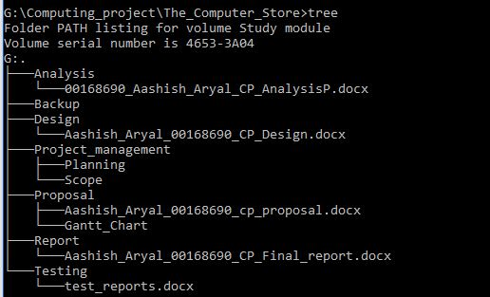  
 *Fig () Configuration management*

The configuration management remain same as initial proposed. As shown above image, I have manually managed files and folders that shows hierarchy of the all the contents of the project in the documentation report. Here I have created 7 directories which named as Analysis, Design, Project management, Proposal, Report, Testing and Backup. All the files related are kept in separate directories in the hierarchical order. I have used Report directory to store all the images and final document. Similarly, Analysis and design document are kept inside the individual analysis and design folder respectively whereas testing folder is used to store all the test reports. Also I have included proposal report in Proposal directory.